**Acheev Bhagat (UID: 114714336)**

**Matlab 4**

**Problem 1:**

eigvalProd =

-0.0431 + 0.0000i

eigPoly =

1.0000 -3.6765 1.2131 -0.4712 -1.5105 0.4632 -0.0431

eidDet =

-0.0431

**Problem 2:**

P =

-0.6325 0.2626 0.0170 -0.7342

-0.3162 -0.1313 0.7800 -0.4127

0.3162 -0.9191 0.5257 -0.5198

-0.6325 0.2626 -0.3391 -0.1429

D =

5.0000 0 0 0

0 1.0000 0 0

0 0 -2.0000 0

0 0 0 -2.0000

PDP =

1.6653e-15

The value is extremely small, so accounting for rounding error the answer is correct.

**Problem 3:**

P =

-0.8642 0.7549 -0.0000 -0.9632

0.2357 -0.3397 0.6396 -0.2431

-0.3143 0.4152 -0.6396 0.1138

-0.3143 0.3774 -0.4264 0.0134

D =

5.0000 0 0 0

0 4.0000 0 0

0 0 2.0000 0

0 0 0 4.0000

The basis consists of the vectors in matrix P.

**Problem 4:**

P =

-0.4082 0

-0.8165 -0.4082

C =

-0.6000 -0.8000

0.8000 -0.6000

**Problem 5:**

The origin of the dynamical system looks like a saddle point. On eigenvalue is greater than 1, and the other is less than 1, so the eigenvalues support this.

eig =

1.3275 0

0 0.5725

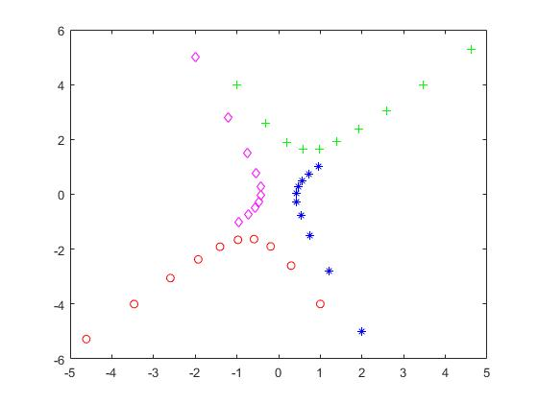

**Problem 6:**

The origin of the dynamical system looks like either an attractor or a repeller. The absolute values of the eigenvalues are less than 1, so the system is an attractor.

D =

0.9000 + 0.2000i 0.0000 + 0.0000i

0.0000 + 0.0000i 0.9000 - 0.2000i

eigval1 =

0.9220

eigval2 =

0.9220

